**MongoDB Task**

1. Find all the information about each products?

Command: db.product_details.find()

Screen Shot of output:

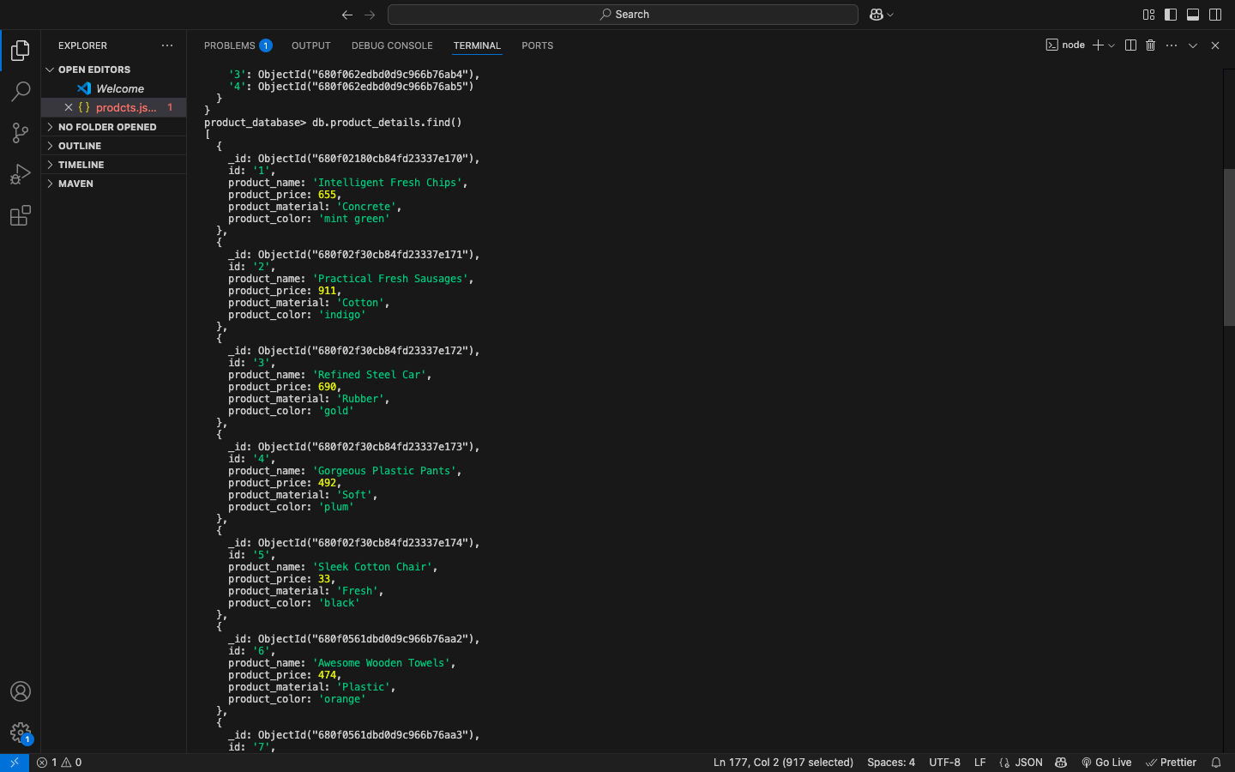

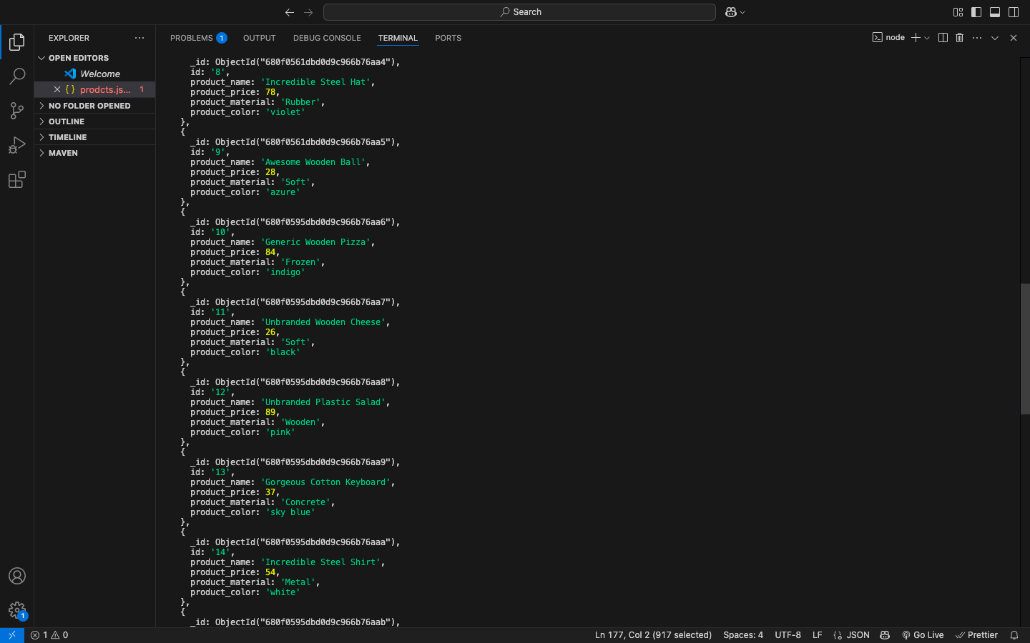

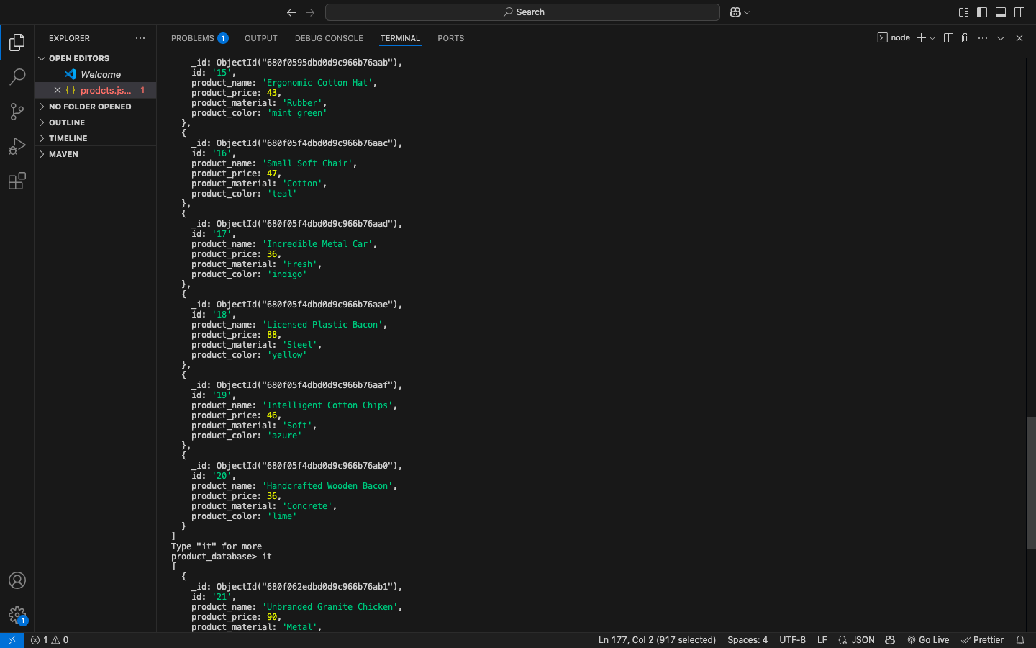

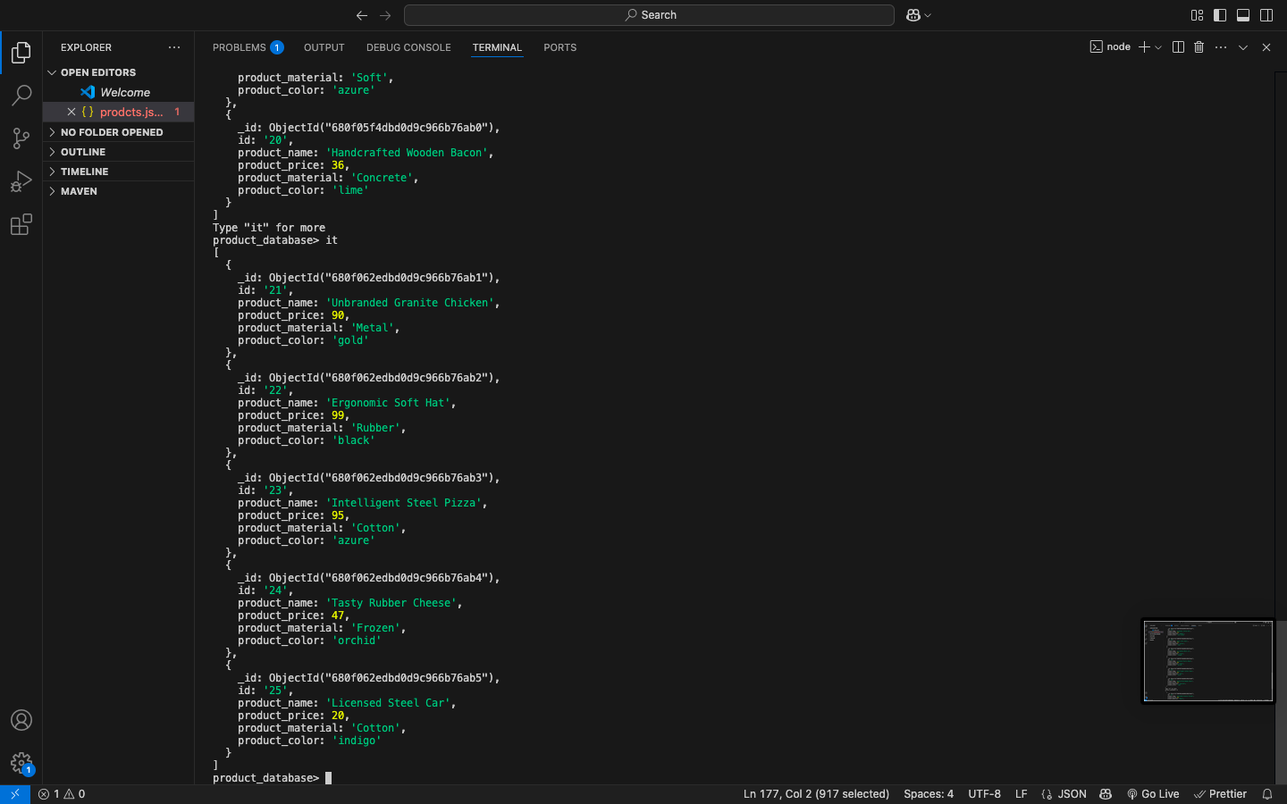

1. Find the product price which are between 400 to 800?

Command: db.product_details.find({product_price : {$gte:400,$lte:800 }})

Screen Shot of output:

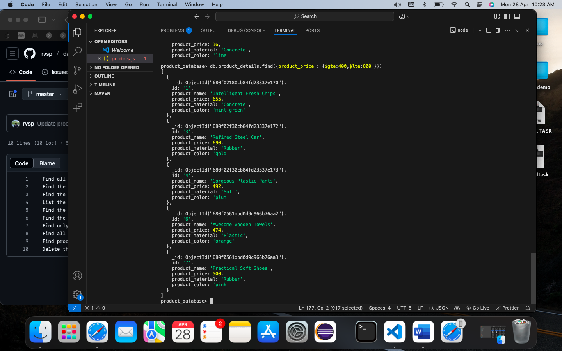

1. Find the product price which are not between 400 to 600?

Command: db.product_details.find({

$or:[

{product_price:{$lt: 400 }},

{product_price:{$gt: 600 }}

]

})

Screen Shot of output: 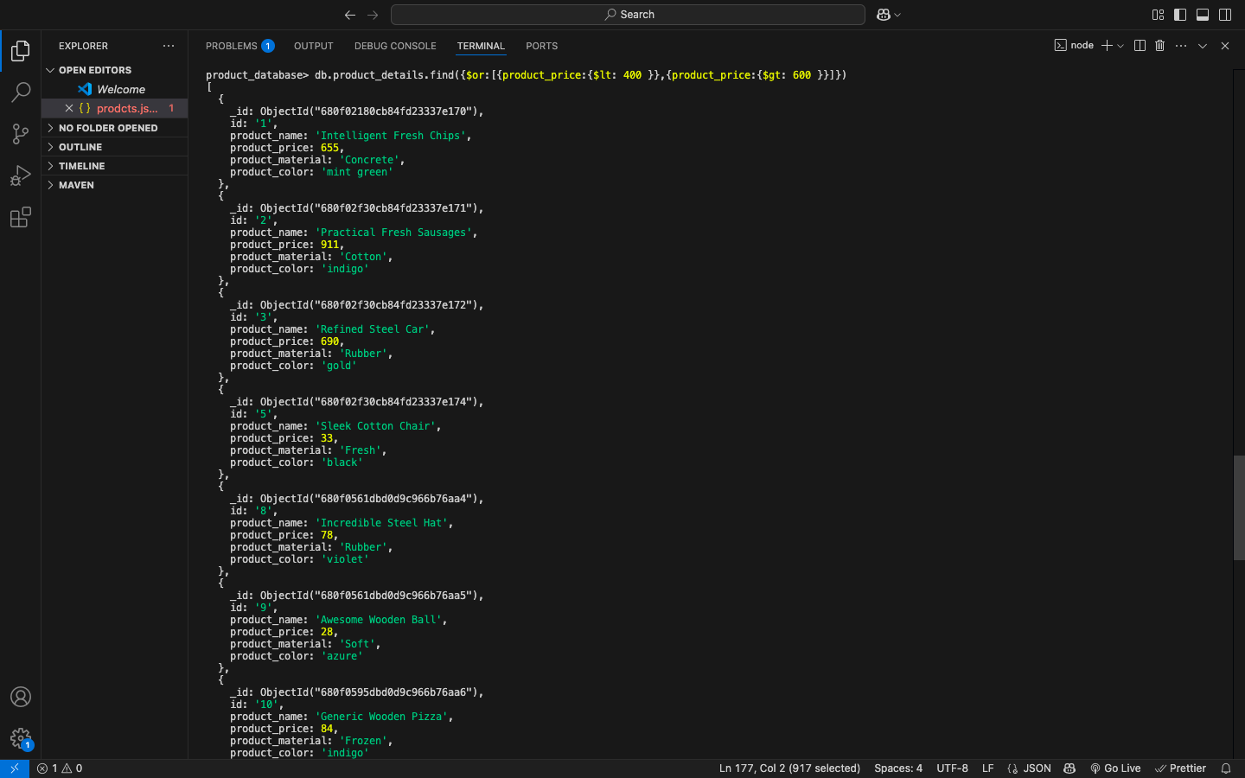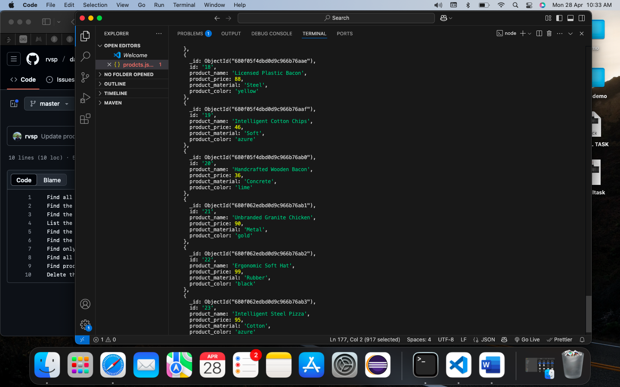

1. List the four product which are greater than 500 in price ?

Command: db.product_details.find({product_price : {$gt:500 }}).limit(4)

Screen Shot of output: 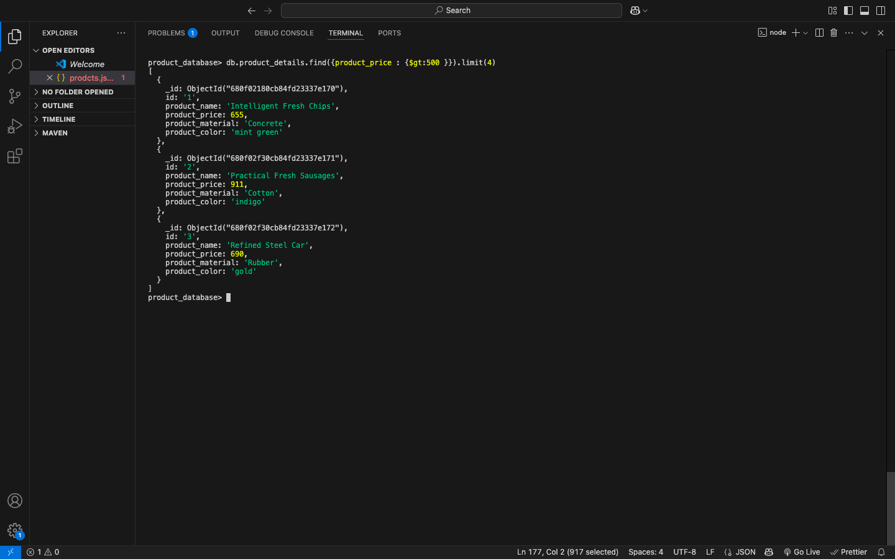

1. Find the product name and product material of each products?

Command: db.product_details.find({},{product_name:1,product_material:1,_id:0})

Screen Shot of output: 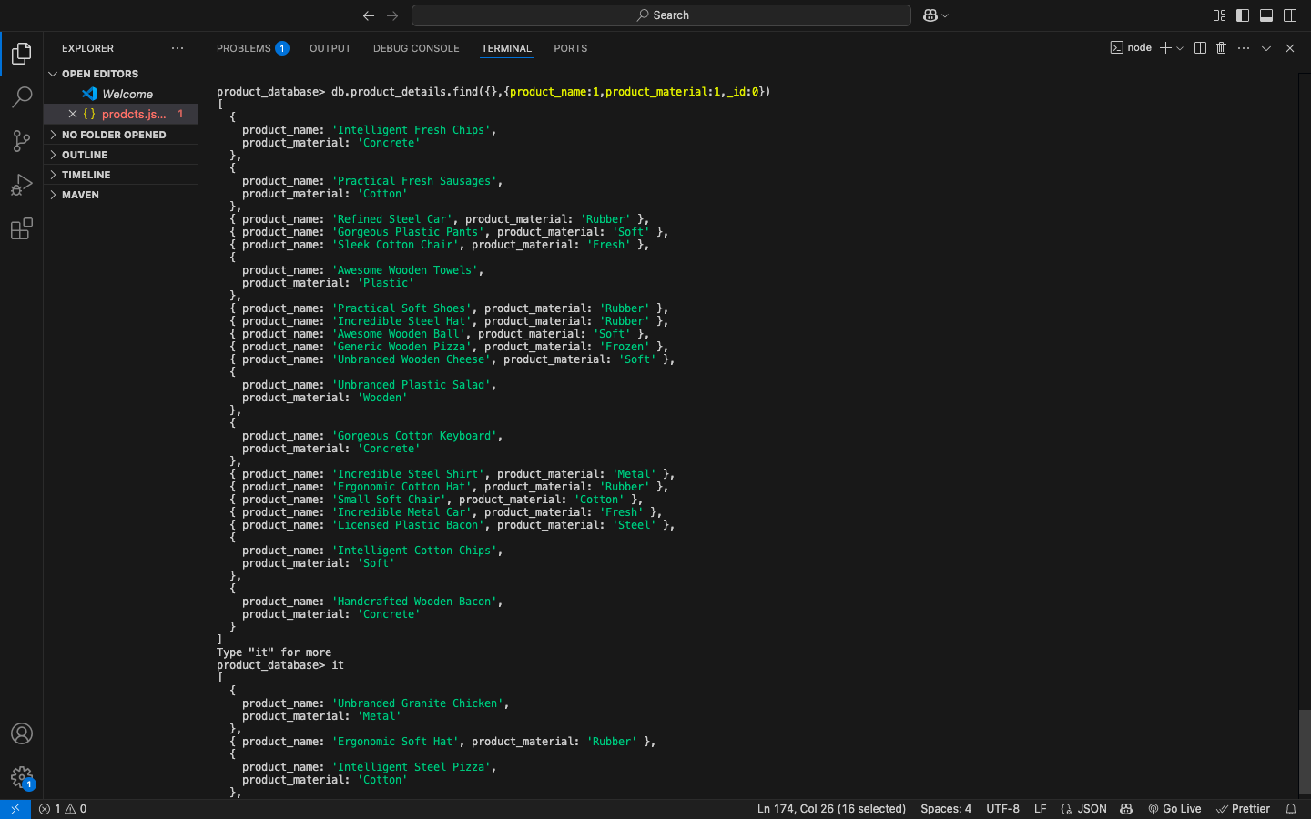

1. Find the product with a row id of 10?

Command: db.product_details.find({id:"10"})

Screen Shot of output: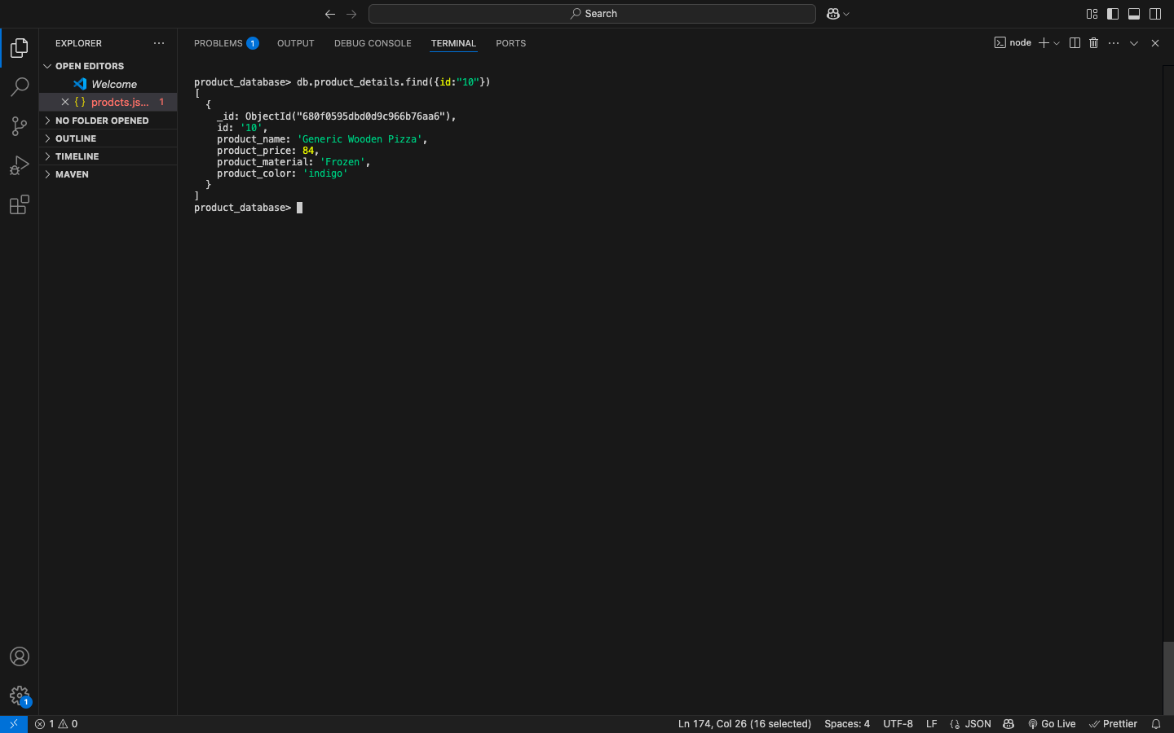

1. Find only the product name and product material?

Command: db.product_details.find({},{product_name:1,product_material:1,_id:0})

Screen Shot of output:



1. Find all products which contain the value of soft in product material ?

Command: db.product_details.find({ product_material: { $regex: "soft", $options: "i" }})

Screen Shot of output: 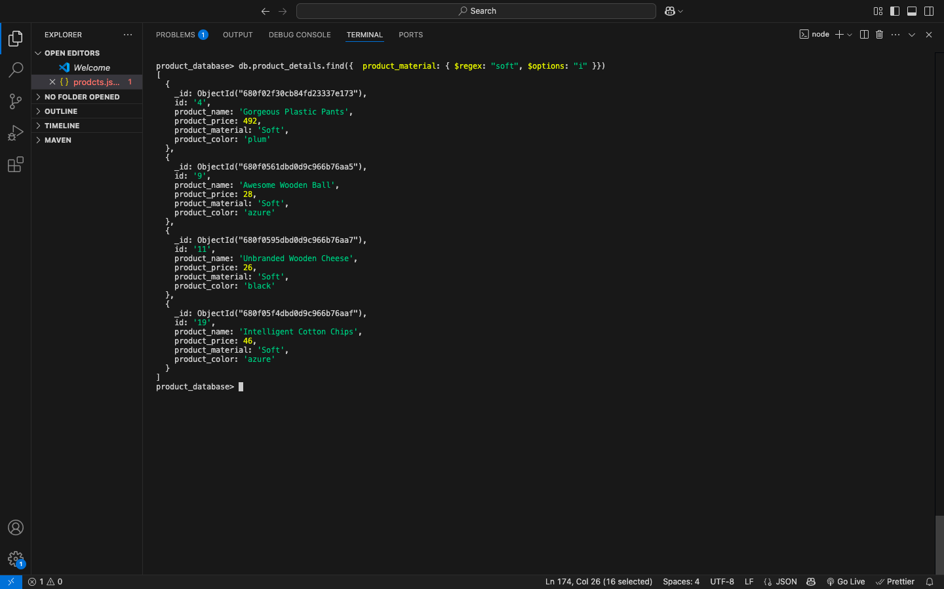

1. Find products which contain product color indigo  and product price 492.00?

Command: db.product_details.find({$or:[{product_color:"indigo"},{product_price:492.00}]})

Screen Shot of output: 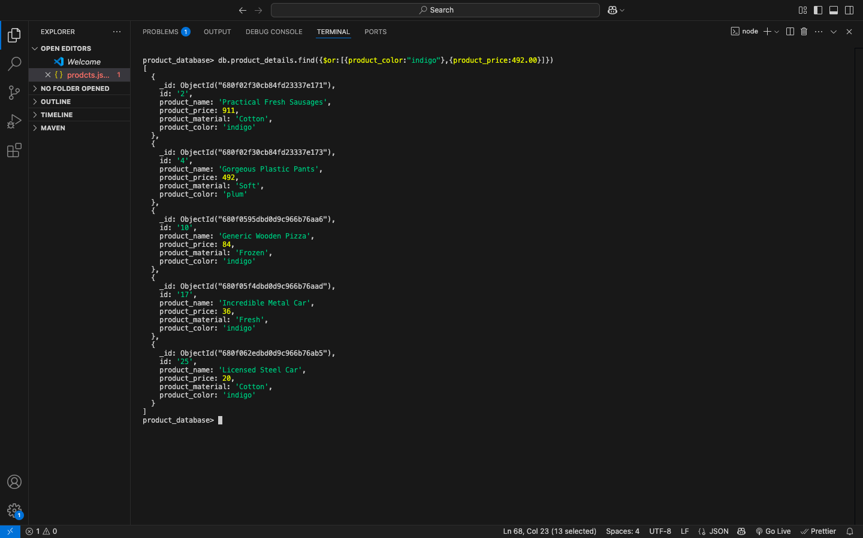

1. Delete the products which product price value are 28?

Command: db.product_details.deleteMany({product_price:28})

Screen Shot of output: 